DISPOSE OF MASKS AND GLOVES PROPERLY
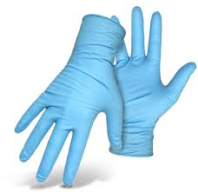
THEY BELONG IN THE
GARBAGE CAN
Mansfield Township
Clean Communities
NOT IN RECYCLING
NOT ON THE GROUND

