IN HONOR OF AMERICA’S 250TH ANNIVERSARY
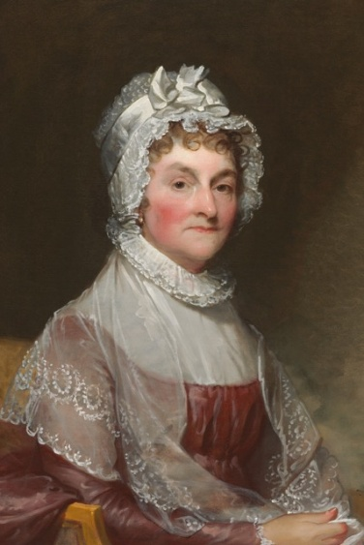
Abigail Adams
1744 – 1818
Abigail Adams was an advisor, writer, and trailblazer. She wrote to her husband John Adams to “remember the ladies” as the Continental Congress gathered in 1776. She would write “Do not put such unlimited power into the hands of the Husbands. Remember all Men would be tyrants
if they could”. Abigail was born in Massachusetts, and although she had no formal education, she was a voracious reader.
She met lawyer John Adams who shared her intellectual interests. They were married and had five (5) children, including the future sixth (6th) president, John Quincy Adams.
Leading up to the Revolutionary War, John Adams was frequently away. They would correspond about their children and the need for colonial America to abolish slavery. During this time, Abigail ran the farm, keeping the family afloat through her thriftiness.
When John Adams became vice president, and then second president of the United States in 1797, Abigail often joined him in New York, Philadelphia, and Washington, DC., taking on the duties as hostess. The Adams family became the first family to live in the White House, and Abigail continued to advise her husband on political affairs. In fact, some called her “Mrs. President, suggesting she might have had too much influence.”
When John Adams lost reelection in 1800, they moved to Quincy, and Abigail devoted herself to her family and their son’s political career. In 1818, Abigail Adams died of typhoid fever, but her letters and legacy have forever shaped the American story.

